Tips & Resources

Overall Tips: Set up your Recording Space
- Each piece should be filmed/uploaded as a separate piece of media. No continuous videos.
- Students are encouraged to use standard technology/recording devices available to them (i.e. smartphones, tablets, etc.)
- Solid-colored walls are ideal, but any background that does not steal the focus from your performance is desired.
- Take care that your space allows for adequate lighting. Having a lamp or window directly behind you will cast a shadow over your face. Keep the lighting source behind your recording device or to the side of you so that your face is lit.
- When using pre-recorded music, place the music source (the speaker) closer to you than it is to the device on which you are recording. By having the accompaniment near you, your voice and music will reach the microphone on your device in a more balanced manner.
- Before filming, do a trial run to test both your audio & visual presentation. Watch your video back to ensure everything looks AND sounds okay.
- Ensure the camera portion of your device is at eye level (see example). You can use a tripod built for a smartphone or tablet. If you do not have a tripod, consider using a stack of books on a desk or box. Filming in “landscape” (horizontally) is recommended.

Slating Tips

Labeling Guidelines for All Videos
Label each video file with the piece you are performing, the show or playwright, and your first & last name.
- Title of Song – Musical/Show – Your First & Last Name
- Title of Play – Playwright – Your First & Last Name
Examples:
- Slate – James Smith
- Your Daddy’s Son – Ragtime – Minnie Mouse
- Much Ado About Nothing – William Shakespeare – Luke Skywalker

Time Guidelines for All Performance Videos
All song, monologue, dance, ballet, and wild card videos are recommended to be between 60-90 seconds each.

Framing for Slates, Songs, and Monologues
Camera framing is simply the placement and position of the actor in the shot. We recommend a waist up frame so we can see your face and hear you clearly.
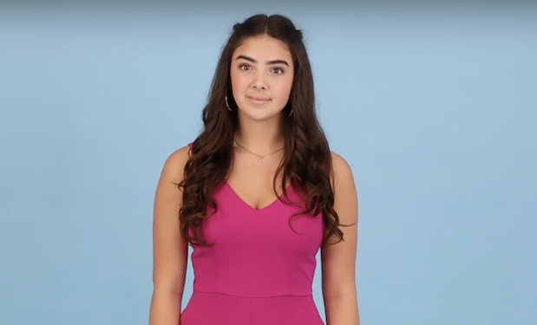

Framing for Dance and Ballet
We recommend a setup that allows us to see the top of your head to the floor. This allows us to see how you inhabit space.

Framing for Dance and Ballet Tip:
If it is helpful for you to see yourself, place a full-length mirror behind the filming device and remember that the camera is your audience.
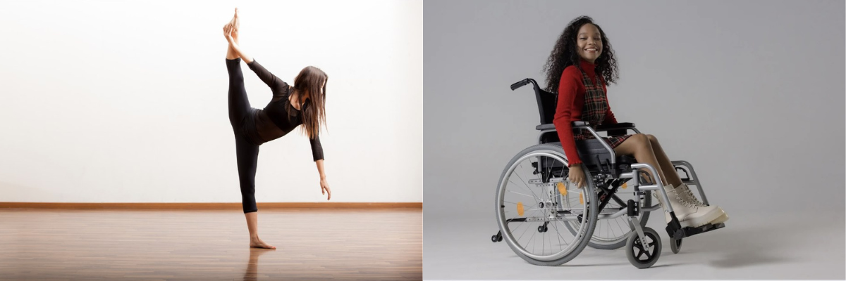

Song Tips
- Some examples of contrasting songs are fast tempo vs slow tempo, sustained melodic singing vs speech-like singing, dramatic vs comedic, belt vs head/falsetto mix.
- Many accompaniment tracks are available on YouTube and other websites. If you do not have a way to work with a live accompanist or don’t have access to a recorded track of your music, consider using an app that will play the piano part for you. Harmony Helper is one such app that allows you to take photos of your sheet music, upload them to the app and then generate a piano track that you can use.

Monologue Tips
It is recommended to choose monologues that are age-appropriate (generally within 5-10 years of your actual age) and that feel authentic to your culture, background, and lived experience.
Active monologues are often better for auditions; an active monologue takes place in real time and focuses on what you want and puts you in direct communication with an imaginary scene partner. This is often more successful in an audition situation than pieces that are a story or remembrance. Additionally, it can be helpful to avoid monologues that rely on extreme emotions as it can be hard to believably justify those responses in a short piece.

Dance Tips
- Make sure you can execute all the choreography well. It is to your advantage to choose steps and movement that highlight your strengths instead of your weaknesses.
- You may use recent videos of you from a show or concert, but it must just be you in the frame.
- Dance sample should be in whatever dance discipline you feel most confident. This may include, but is not limited to jazz, ballet, tap, modern, hip hop, lyrical, contemporary, or dance styles beyond American and Euro-western styles.
- Dance media can be “self-choreographed”, but it must be a solo video of you. This can include a show, competition, or other performance so long as you are clearly featured on your own.
- Please use steps, movement, and physical vocabulary that you are familiar with and can execute well. Fully move your body to the best of your ability.
- To assist applicants with the dance prescreen, several institutions provided the following resource videos for applicants who do not have access to a choreographed combo for the prescreen process. You may submit this choreography (or a combination of it) to any of the schools you are applying to that ask for a dance prescreen. This list will be updated as more institutions share resources, so be sure to check back.
- Abilene Christian University Dance Combo Resource
- Emerson College Dance Combo Resource
- Nazareth University Dance Combo Resource
- Texas State University Dance Combo Resource

Wild Card Tips
- Think about the wild card section as an opportunity to show your personality. Don’t limit yourself, but make sure you teach the adjudicators something about you. Below is a list of ideas that have been successful in the past:
- Singing a pop song
- Performing your own SNL-styled skit where you create a comedic character
- Sharing a hobby or activity that means something to you
- Performing in a language other than English in which you are fluent
- Playing an instrument
- Making a “how-to” video on something you are an expert at
- Performing a poem, song, or dance you created yourself

